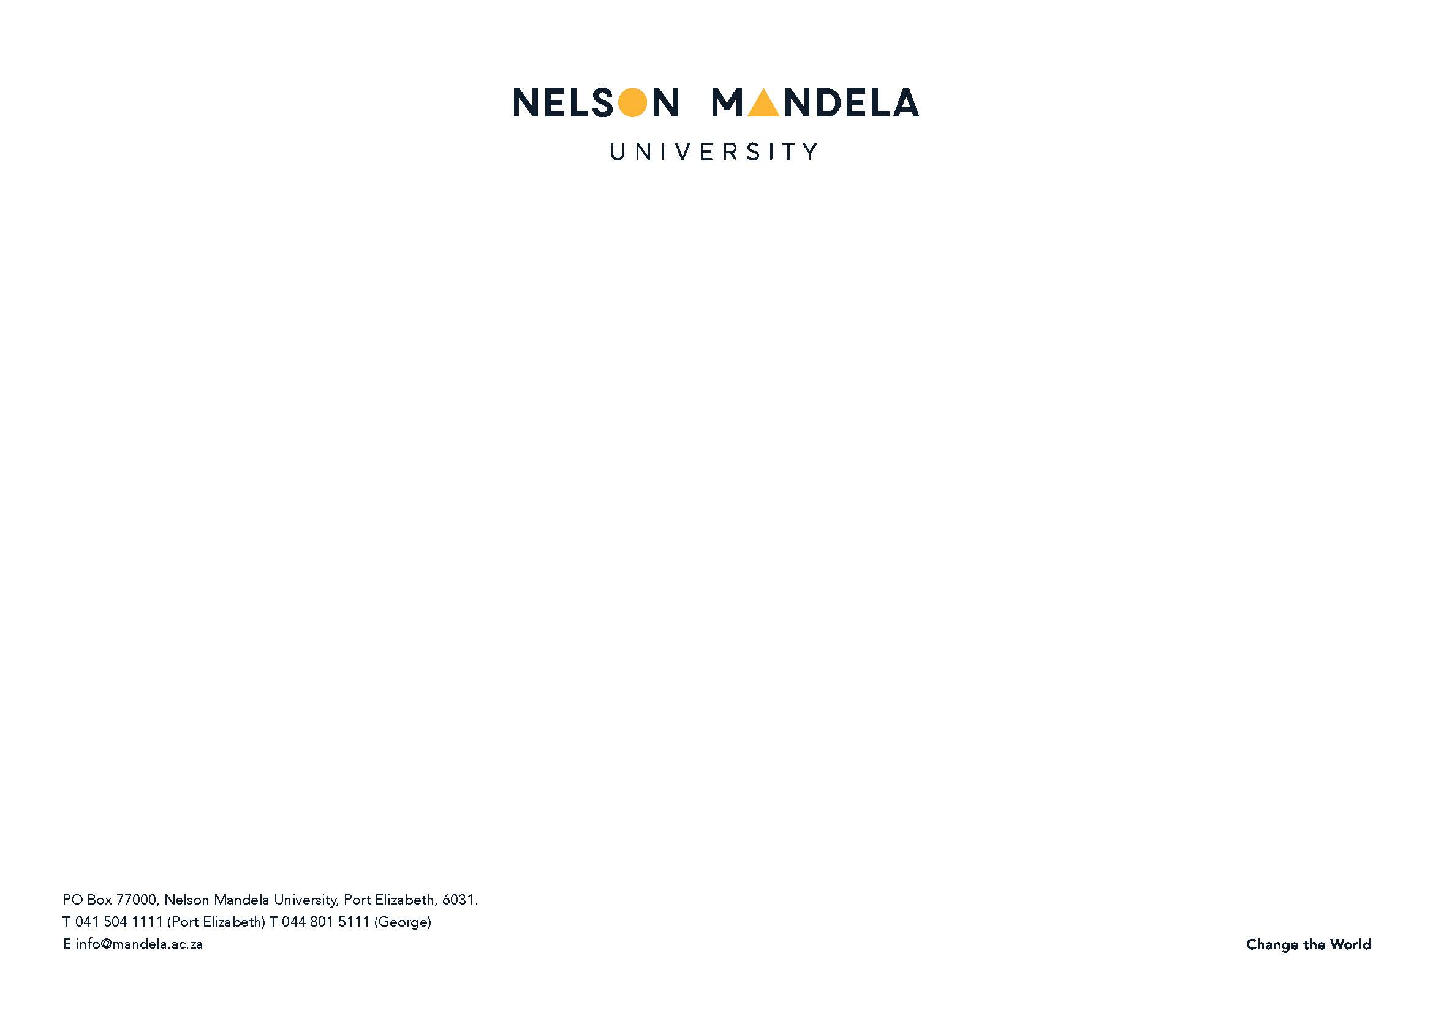

**Curriculum**

| **Module Name** | **Module Code** | **Presented** | **Credits** | **NQF Level** |
| --- | --- | --- | --- | --- |
| Advanced Project Management | SOA552 | 2nd Semester | 20 | **9** |
| Advanced Public Policy Analysis and Planning | SOA551 | 1st Semester | 20 | 9 |
| Administration for Development | SOA561 | 1st Semester | 20 | 9 |
| Professional Ethics for Public Managers | SEE552 | 2nd Semester | 20 | 9 |
| Advanced Local Government Administration | SOA562 | 2nd Semester2 | 20 | 9 |
| Treatise | SOA 550 | Year | 90 | 9 |

**Outcomes**

Learners are equipped to pursue careers as experts in in all facets of public finance, state security, domestic security, foreign affairs, education, manpower, commerce and industry, economics and matters of local interest. They ensure and maintain the welfare of the community he/she serves.

**Modules**

Six compulsory modules

**DURATION**  
A minimum of one year of full-time study or two years of part-time study.

**MASTER OF PUBLIC ADMINISTRATION (COURSE WORK AND RESEARCH):** **FULL-TIME/PART-TIME   
(QUALIFICATION CODE: 19550 – A1/A2)  
(NQF LEVEL: 9, TOTAL NQF CREDITS FOR QUALIFICATION: 190**

**MORE INFORMATION**

**Prof R S Masango or Ms Siyasanga Booysen**

Telephone: (041) 504 2035 or (041) 504 2263

Fax: (041) 5041461

E-mail: [rsmasango@mandela.ac.za](mailto:rsmasango@mandela.ac.za)

E-mail: [Siyasanga.Booysen@mandela.ac.za](mailto:Siyasanga.Booysen@mandela.ac.za)

Student Admissions

Tel: 041 504 3619

Fax: 041 504 2574

E-mail:[POSTGRADUATEADMISSION@mandela.ac.za](mailto:POSTGRADUATEADMISSION@mandela.ac.za)

**Master of Public Administration**

**INTRODUCTION**

Nelson Mandela University opened on 1 January 2005, the result of a merger of the PE Technikon, the University of Port Elizabeth and the PE campus of Vista University. Drawing on the merger partners' track record of more than a century of quality higher education, research and technological innovation, NMU brings together the best of career-focused and academic education - a dual university offering both general and professionally oriented university programmes as well as technologically and career oriented programmes from the entrance level (certificate level) through to the research level (PhD level).

**Admission Requirements:** An Honours degree in Public Administration.

**MASTER’S DEGREE IN PUBLIC ADMINISTRATION (MPA)**

The MPA degree from the NMMU is an internationally accredited professional postgraduate programme designed to enhance the knowledge and skills of public managers. The programme may be studied in either semi-distance education or part-time format